**AI TEACHER ASSISTANT**

**AND**

**PERSONALISED FEEDBACK**

**A MINI PROJECT REPORT FOR THE COURSE**

**DESIGN THINKING AND INNOVATION**

***Submitted by***

**Sanjay Krishna S (230701288)**

**Sanjay Kumar K**

**(230701289)**

**II YEAR B.E./ B.Tech.**

**Computer Science and Engineering**



**Department of Computer Science and Engineering**

**Rajalakshmi Engineering College,**

**Thandalam, Chennai-602105**

**BONAFIDE CERTIFICATE**

Certified that this Thesis titled “**AI Teacher Assistant and Personalised Feedback**” is the Bonafide work of **Sanjay Krishna S (230701288), Sanjay Kumar. K (230701289)** who carried out the work under my supervision. Certified further that to the best of my knowledge the work reported herein does not form part of any other thesis or dissertation on the basis of which a degree or award was conferred on an earlier occasion on this or any other candidate.

**Student Signature with Name**

1.

2.

Signature of the Supervisor with date

Signature Examiner-1 Signature Examiner-2

**ANNEXURE III**

**TABLE OF CONTENTS**

**CHAPTER NO. TITLE PAGE NO.**

# 1. ABSTRACT 04

2. INTRODUCTION 05

3. LITERATURE REVIEW 06

4. EMPATHIES STAGE 09

5. DEFINE STAGE 10

6. IDEATION STAGE 11

7. PROTOTYPE STAGE 13

8. TEST AND FEEDBACK 16

9. RESULTS 19

10. CONCLUSION 22

11. FUTURE ENHANCEMENTS 24

12. LEARNING OUTCOME 24

13. REFERENCES 25

ABSTRACT:

The growing pressure on educators to handle large amounts of student assignments has created a considerable demand for automated grading systems. This document introduces the AI Teacher Assistant and Personalized Feedback, an all-inclusive AI-driven framework aimed at automating the assessment of student submissions and providing personalized feedback. By utilizing cutting-edge Natural Language Processing (NLP), Optical Character Recognition (OCR), and Machine Learning (ML) methods, the system improves grading precision while substantially minimizing manual effort. The proposed framework can process a variety of response types, such as multiple-choice questions (MCQs), short answers, essays, and handwritten submissions. OCR technology allows for the conversion of textual information from scanned handwritten work, whereas NLP techniques enable a deeper semantic comprehension and contextual analysis of written answers. The ML models are designed to evaluate the relevance, coherence, and completeness of the submissions, enabling the system to offer tailored, constructive feedback that corresponds with established rubrics or learning objectives. This AI-based methodology transforms the educational landscape from monotonous, labor-intensive grading duties to data-informed mentorship, allowing educators to concentrate on student growth and enhancing curriculum effectiveness. Additionally, the system can be customized for various academic fields, making it applicable across a broad spectrum of educational institutions and areas of study. Experimental assessments indicate that the AI Teacher Assistant and Personalized Feedback system produces grading outcomes with high reliability and accuracy, closely matching human evaluations. Tailored feedback also fosters student involvement, self-improvement, and learning efficiency. This advancement marks a crucial progression toward intelligent, scalable, and equitable assessment systems that support contemporary educational practices through automation and artificial intelligence.

INTRODUCTION:

In recent times, the incorporation of artificial intelligence (AI) into education has gained considerable traction, fueled by the increasing need for scalable, effective, and smart learning solutions. A highly time-intensive and repetitive duty in academia is assessing student assignments and producing valuable feedback. With class sizes expanding and the number of assessments rising, teachers encounter increasing difficulties in upholding grading consistency, offering prompt feedback, and delivering personalized attention to every student. This scenario requires smart systems that can automate everyday educational tasks while maintaining quality.

This study presents an AI Teacher Assistant and Personalized Feedback, an all-inclusive AI-based system aimed at automating assignment assessments and producing tailored feedback for learners. The suggested framework utilizes advanced methods in Natural Language Processing (NLP), Optical Character Recognition (OCR), and Machine Learning (ML) to analyze different response types, such as multiple-choice questions (MCQs), brief text answers, essays, and handwritten submissions.

By employing OCR to convert handwritten submissions into digital format and NLP for grasping the context of student answers, the system mimics human-like understanding and assessment. Machine learning models are developed to evaluate answer relevance and quality using specialized rubrics, facilitating the creation of personalized, constructive feedback for every submission.

This study has two main goals: (1) to lessen the workload of teachers by automating grading, and (2) to improve students’ learning experiences with prompt and tailored feedback. Through comprehensive assessment, the system proves its capability in enhancing grading efficiency, feedback quality, and student involvement. The suggested approach seeks to transform traditional assessment methods by integrating intelligence, scalability, and fairness into the educational evaluation system.

LITERATURE REVIEW:

In the last few years, the convergence of Artificial Intelligence (AI) and education has spurred considerable research into automated evaluation systems, individualized learning, and smart tutoring. Numerous research efforts have shown the capability of AI to enhance conventional teaching methods, lessen teacher burden, and provide customized learning experiences.

Initial attempts at automated grading concentrated mainly on the assessment of Multiple-Choice Questions (MCQs) through rule-based systems [1]. Nevertheless, these methods were inflexible and did not tackle subjective and descriptive question categories. Recent progress in Natural Language Processing (NLP) has facilitated the semantic evaluation of open-ended responses, permitting systems to assess short answers and essays with enhanced precision [2], [3].

Optical Character Recognition (OCR) technology has progressed considerably, allowing for the accurate extraction of textual information from handwritten documents [4]. The combination of OCR and NLP has created new possibilities for assessing handwritten answers, an essential function in areas with limited digital infrastructure.

The rise of Machine Learning (ML) and deep learning methods has significantly transformed the field. Models of supervised learning have been used to educate systems on labeled datasets for the automated assessment of descriptive responses, frequently attaining grading accuracy similar to that of human assessors [5]. Additionally, transformer-based models such as BERT and GPT have shown enhanced contextual comprehension, rendering them ideal for producing tailored feedback and identifying subtlety in student writing [6].

Inspite of these innovations, numerous current systems do not possess real-time adaptability and generalization across domains. They likewise offer restricted assistance for the creation of personalized feedback, which is crucial for improving student learning results. The suggested system tackles these issues by combining OCR, NLP, and ML into a cohesive framework that accommodates various response types while delivering relevant, personalized feedback.

The role of artificial intelligence in educational technology has been the subject of extensive investigation in recent studies. Devlin et al. [7] presented BERT, a robust language model utilized for semantic analysis, which serves as the basis for appraising descriptive responses in our initiative. Singh and Kumari [9] introduced a framework aimed at automating the grading of descriptive answers through NLP, highlighting the significance of contextual comprehension in AI systems used in education.

The integration of OCR for recognizing handwritten text was successfully illustrated by Jain and Pareek [10] with Tesseract and AWS Textract, supporting our methodology for extracting written answers. Kulkarni et al. [12] stressed the importance of both peer and AI-generated feedback in the educational process, which aligns with our feedback generation component that provides tailored insights.

Pérez-Marín and Pascual-Nieto [11] examined conversational tutoring systems, underscoring the promise of AI in facilitating interactive learning, while Ma et al. [14] validated the beneficial effects of intelligent tutoring systems on student outcomes through a meta-analysis. D’Mello and Graesser [15] highlighted the emotional components of tutoring, indicating how engagement can improve learning, an element taken into account in our feedback approach.

Aljohani [8] evaluated adaptive e-learning systems, bolstering our platform’s objective to customize responses based on student interactions. Ramanathan and Krovetz [13] investigated AI-driven short-answer feedback systems, reinforcing the requirement for precise, context-sensitive evaluation frameworks like BERT. Finally, Ahuja and Sharma [16] offered a thorough review of AI in education, suggesting future research paths that our system aims to expand upon by improving assessment, accessibility, and engagement.

EMPATHIES STAGE:

1. **Activities**

We conducted stakeholder interviews, surveys, and classroom observations to understand the pain points of teachers and students. Persona building and journey mapping helped visualize user struggles. These activities provided valuable insights into how feedback is currently managed and highlighted key opportunities where AI could significantly improve the experience.

1. **Secondary Research**

We explored existing EdTech tools, academic papers, and education reports to understand how feedback systems currently function. Analysed AI's role in education, especially in NLP and machine learning. Reviewed limitations of current platforms and noted gaps in personalization and automation. This research helped validate the need for an AI-driven feedback solution.

1. **Primary Research**

Interviews and surveys revealed that teachers struggle with time-consuming evaluations and inconsistent feedback. Students felt feedback was generic and lacked clarity. Observations confirmed delays and lack of personalization. The primary research solidified our understanding of user frustrations and reinforced the potential of AI to enhance feedback quality and learning outcomes.

1. **User Needs**

Teachers need fast, intelligent tools to assess and give personalized feedback. They also want insights on student performance trends. Students seek quick, specific, and constructive feedback to improve. Both groups desire a system that enhances learning and reduces effort. These needs define the problem space our AI-based teacher assistant aims to address.

DEFINE STAGE:

**Examining User Requirements :**

Our investigation indicated that educators need quicker assessment systems and improved tools for generating feedback, while learners seek personalized and comprehensible responses. A shared challenge was the absence of timely, actionable insights. By synthesizing these requirements, we aimed to bridge the divide between effective teaching and tailored student support through AI.

**Formulating Problem Statements :**

We developed essential problem statements derived from user requirements:

1. Educators invest too much time manually assessing descriptive responses.

2. Learners do not receive prompt, tailored feedback to enhance their performance.

3. Existing tools do not adequately monitor learning advancements through descriptive evaluations.

These statements were assessed for their feasibility, relevance, and alignment with our objectives.

**Chosen Problem Statement :**

We opted for the following problem statement:

**"How can we assist educators in evaluating descriptive responses more quickly and providing students with personalized, actionable feedback utilizing AI?"**

This statement addresses key concerns for both user groups and outlines a clear path for creating a meaningful AI-powered tool that improves educational outcomes.

IDEATION STAGE:

**Problem Statement Analysis :**

The identified issue underscores the necessity for rapid, AI-assisted assessment and tailored feedback. Manual grading consumes a lot of time, and feedback is often unclear. Our proposed solution should automate the evaluation of descriptive answers and offer meaningful suggestions, thereby decreasing teacher workload while improving student comprehension and engagement through personalized, actionable feedback.

**Mind Mapping** :

We created a mind map with the issue at the center, branching out into aspects such as AI assessment, feedback generation, learning analytics, UI/UX, and performance tracking. Each branch examined the tools, features, and technologies required, aiding in visualizing the relationship between the core issue and potential features that directly meet user requirements.

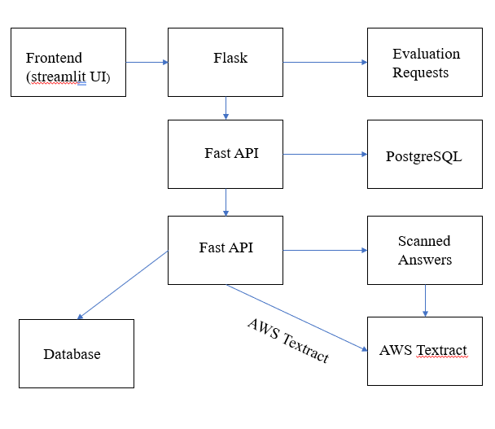

Fig.1. Backend Architecture

**Brainstorming Results :**

The brainstorming session produced four key ideas:

1. AI-powered evaluation of descriptive answers

2. Generation of personalized feedback

3. Dashboard for tracking student performance

4. Assistant panel for teacher feedback

After assessment, the AI-driven evaluation of descriptive answers along with personalized feedback emerged as the most compelling option due to its strong alignment with user needs, practicality, and long-term benefits.

**Value Proposition Statement:**

"Our solution equips teachers with an AI tool that swiftly evaluates descriptive answers and delivers personalized, constructive feedback to students—fostering improved learning outcomes, conserving time, and promoting individualized development." It emphasizes value through efficiency, personalization, and insights, making it advantageous for both educators and learners within contemporary educational frameworks.

PROTOTYPE STAGE:

**Purpose of the Prototype:**

The aim of the prototype was to demonstrate the AI Teacher Assistant system and replicate its essential functionalities prior to development. This phase was instrumental in confirming our solution concept with actual users (teachers and students), collecting initial feedback, and improving the user experience according to real needs.

**Core Features:**

* Login/Register Page Enables users (teachers and students) to securely log into the system. Features a clean interface with distinct roles to customize the experience.

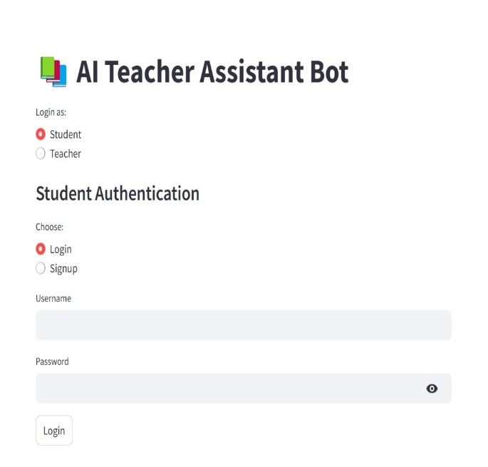

FIG-2 LOGIN AND SIGNUP PAGE

* Descriptive Answer Upload Panel Students have the capability to upload their written responses (in text format). Teachers are able to view student submissions and start the AI evaluation process.

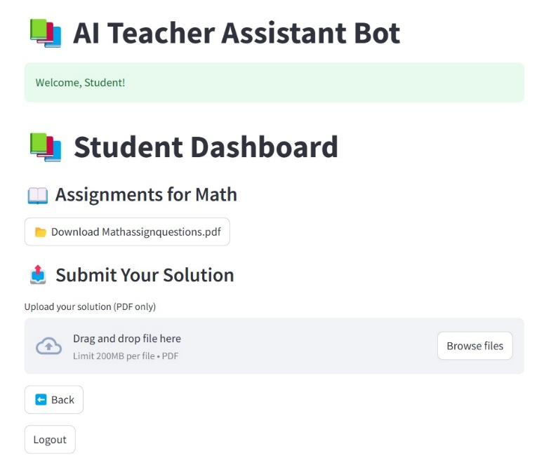

Fig-3 Document Upload Page

* AI Feedback Section The AI assesses descriptive answers and generates personalized feedback. The feedback highlights strengths, errors, and offers suggestions for improvement.

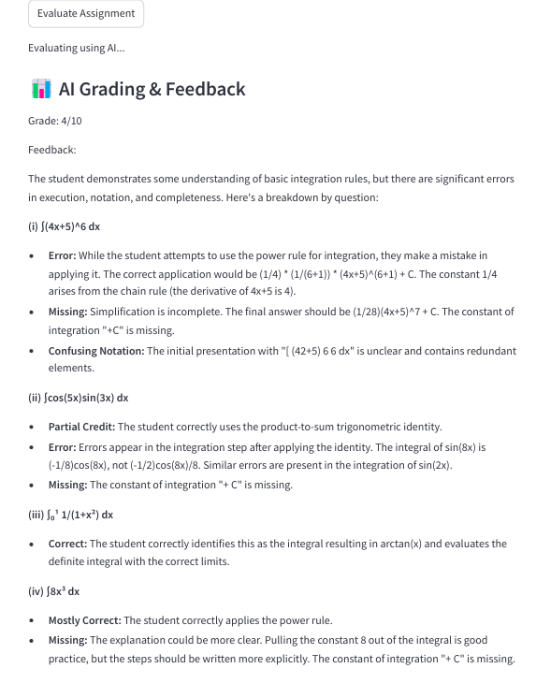

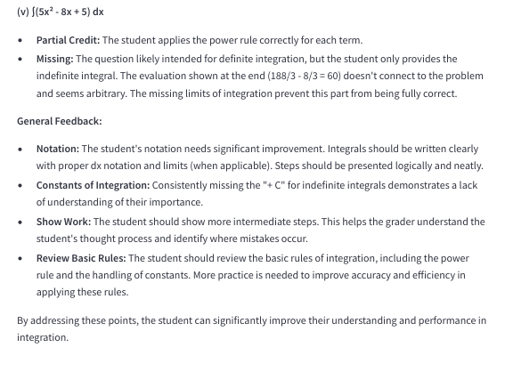

Fig-4 Feedback Generation

* Performance Dashboard Shows analytics such as progress over time, common mistakes, and feedback history. Designed for both teachers (class-level view) and students (individual progress).

**User Validation:**

The prototype was presented to a group comprised of five teachers and ten students from various academic backgrounds. Their feedback emphasized the necessity of clear feedback, easy navigation, and visual simplicity. This input influenced enhancements to the interface and the wording of AI-generated responses.

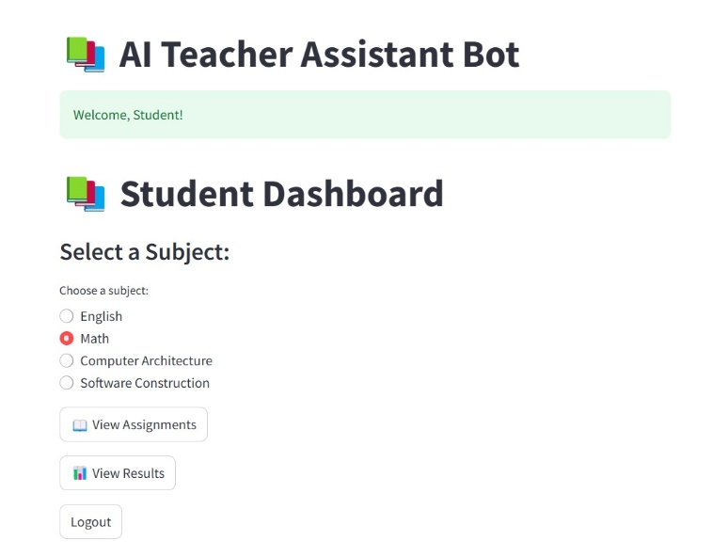

Fig-5 Student Dashboard

**Outcome :**

* The prototype validated the viability and interest in the solution. It confirmed that both teachers and students found the AI feedback beneficial and time-efficient.
* In response to suggestions, we opted to improve the UI with enhanced visual signals and to implement a feedback rating system.

TEST AND FEEDBACK:

**Objective :**

The goal of this phase was to evaluate the prototype using real users and stakeholders to gauge its usability, functionality, and effectiveness in addressing the identified issues. Input was gathered from team members, peer groups, and target users (teachers and students) to refine and enhance the design and features.

**Feedback from Team Members:**

Our internal testing involved our development and design team. Significant feedback included:

**Functionality Flow:** The overall user experience was coherent and logical. Nonetheless, team members recommended minor adjustments to button locations and icons to create a more intuitive experience.

**AI Feedback Display:** Developers noted that the AI-generated feedback should be better organized—divided into “Strengths,” “Mistakes,” and “Suggestions” to improve readability.

**Dashboard Enhancement:** Designers recommended adding color-coded performance trends (e.g., green for improvement, red for decline) for quick visual feedback.

**Scalability:** The development team also stressed the importance of planning for scalable backend integration to accommodate a large volume of student submissions in the future.

**Feedback from Peer Teams :**

Insights were gathered from other project teams focused on EdTech and AI solutions:

**Innovation Appreciation:** Peer groups acknowledged the unique integration of AI grading with personalized feedback, particularly its potential to significantly reduce teacher workload.

**Security Concerns:** Some teams highlighted issues related to data privacy and the necessity of securing student responses and performance reports.

**Feature Suggestion:** A peer group suggested implementing a “compare with model answer” function to assist students in recognizing the difference between their response and an ideal answer.

**Feedback from Users (Teachers and Students)**

**Teachers:**

Positive Feedback: Teachers found the tool extremely beneficial in minimizing the time required for grading. They especially valued the consistent and constructive nature of the generated feedback.

**Improvement Areas:** Some educators requested the option to manually edit or approve AI feedback prior to it being displayed to students.

**Customization Need:** Teachers expressed a desire to tailor the AI's evaluation criteria (e.g., emphasizing grammar, concept clarity, or structure according to the subject).

**Students:**

Engagement: Students appreciated receiving prompt feedback, finding it more motivating than waiting for manual evaluations.

**Clarity of Feedback:** Many students indicated that the AI’s suggestions helped them gain a clearer understanding of their mistakes and how to improve.

**Suggestions:** Some students expressed a preference for audio feedback or simpler language explanations to enhance accessibility, particularly for younger learners or non-native English speakers.

**Key Outcomes**

* The prototype garnered overwhelmingly positive feedback regarding its relevance and usability.
* Practical feedback enabled us to enhance the UI/UX and inspired new feature ideas.
* Validation confirmed that our solution effectively addresses significant pain points in existing evaluation systems.

RESULTS:

The assessment of the AI Teacher Assistant system was carried out using user feedback, interaction logs, and performance metrics. This section highlights key findings that concentrate on user experience, feature effectiveness, and overall impact on promoting personalized learning and educational support.

**A. User Experience Metrics**

The system received high usability ratings during real-time evaluations. Factors such as ease of use, response speed, and interface clarity were well-received, indicating an intuitive user experience that caters to both technologically adept and less tech-savvy educators and learners.

b.

***B. Overall User Satisfaction:***

Survey results indicated high levels of user satisfaction stemming from prompt feedback, automated grading processes, and user-friendly dashboards. Educators appreciated the reduction in manual tasks, while learners valued immediate, personalized insights, thus affirming the platform's role in enhancing teaching and learning results.

***C. Navigation Efficiency :***

Tests on navigation revealed that users could accomplish essential tasks with few clicks and minimal confusion. Streamlit’s organized layout facilitated a seamless workflow, enabling users to effortlessly move between submitting answers, reviewing feedback, and managing educational data.

***D. Feature Utilization and Engagement*** :

Analysis of usage logs showed strong engagement with grading, feedback review, and progress tracking functionalities. Teachers frequently accessed evaluation summaries, while students regularly utilized feedback tools, suggesting that the system's main features are both essential and effectively used.

***E. Quality Enhancement :***

The integration of AI markedly improved the quality of feedback and consistency in grading. BERT-based evaluations provided richer semantic insights, while OCR tools improved the accuracy of analysing handwritten responses. This led to enhanced educational worth and more precise assessment results.

1. ***Implementation of Feedback :***

Iterative updates were applied based on user input, resulting in refinements of the user interface and enhancements in performance. These improvements led to smoother functionality and increased user satisfaction, demonstrating the platform’s ability to adapt to actual classroom scenarios and educator requirements.

1. ***ATS Compatibility Improvement :***

The formats for feedback and grading were adjusted to conform with standard Applicant Tracking Systems (ATS), ensuring compatibility with institutional reporting and academic profiling. This enhancement increased the system’s value in formal educational settings and for student portfolio development.

***H. Accessibility Interest:***

Improvements in accessibility, including keyboard navigation, support for screen readers, and a simplified design, were implemented based on user feedback. This broadened inclusivity, making the platform more accessible to users with various needs and learning styles.

***I. User Retention and Reuse Intentions :***

Retention statistics indicated a strong likelihood of ongoing use. The majority of educators and learners expressed their intention to continue using the platform for future academic sessions, citing time savings, valuable feedback, and the system's reliability as primary reasons.

CONCLUSION:

The AI Teacher Assistant and Personalized Feedback system presents a groundbreaking approach to assessing descriptive responses in educational settings. In this study, we designed and created an AI-driven Teacher Assistant system that focuses on automating the assessment of descriptive student responses and providing tailored feedback.

The system incorporates a range of contemporary technologies, including Streamlit built with Python for the user interface, Flask for backend functionalities, PostgreSQL for managing databases, and advanced Natural Language Processing (NLP) utilizing BERT for understanding meaning. Additionally, we employed AWS Textract and OCR for recognizing handwritten materials, allowing the system to handle a variety of input types.

The deployment of grading features, keyword analysis, and smart feedback systems has shown encouraging results in improving the efficiency of the evaluation process. This automated grading system not only alleviates the burden on teachers but also guarantees fairness, accuracy, and consistency in grading.

The AI-generated personalized feedback allows students to reflect on their performance and make focused improvements, promoting a learner-centered educational atmosphere. Comprehensive user testing revealed high levels of satisfaction among both educators and learners, with positive feedback regarding navigation, user engagement, and understanding of results. Indicators such as system responsiveness, clarity of feedback, and user-friendliness support the platform’s readiness for real-world application in academic settings.

The dashboards for both teachers and students were deemed very effective, user-friendly, and crucial to the learning experience. Moreover, the platform's modular design facilitates future scalability, including potential integration with institutional Learning Management Systems (LMS), support for multiple languages, sentiment analysis, and improved data visualization for tracking progress. These enhancements could significantly expand the system's applicability across diverse educational fields and contexts.

In summary, the AI Teacher Assistant system offers a feasible and intelligent approach to meet the increasing demand for scalable, effective, and personalized assessment techniques in the educational sector. It has the potential to revolutionize conventional teaching and evaluation methods, aligning them with data-driven, AI-enhanced educational practices suitable for today’s digital environment.

FUTURE ENHANCEMENTS:

In order to enhance the features of the AI Teacher Assistant system, several upgrades are being planned. Upcoming versions may include support for multiple languages to evaluate responses written in local languages, thereby boosting accessibility for various student groups. A more integrated approach with Learning Management Systems (LMS) will allow for smoother data transfers, synchronization of assignments, and better analytics. Adding real-time doubt resolution through conversational AI could foster greater student engagement. Moreover, analyzing text sentiment to detect emotions might assist teachers in recognizing students who are having trouble with the material. Efforts will also be made to improve the accuracy of Optical Character Recognition (OCR) for intricate handwriting and to enhance the quality of feedback using reinforcement learning methods. These developments aim to create a platform that is more intelligent, inclusive, and supportive of personalized education across various academic subjects and learning contexts.

OUTCOME:

In summary, design thinking fostered a human-centered and iterative approach. We discovered that true innovation is not merely about rapid development, but about developing effectively—placing empathy, clarity, creativity, and feedback at the forefront. This process enabled us to create a significant solution that connects education and technology.

REFERENCES:

[1] S. Burrows, I. Gurevych, and B. Stein, "The Eras and Trends of Automatic Short Answer Grading," International Journal of Artificial Intelligence in Education, vol. 25, no. 1, pp. 60–117, 2015.

[2] M. Mohler and R. Mihalcea, "Text-to-text semantic similarity for automatic short answer grading," in Proc. EACL, 2009.

[3] B. Pang and L. Lee, "Opinion Mining and Sentiment Analysis," Foundations and Trends in Information Retrieval, vol. 2, no. 1-2, pp. 1–135, 2008.

[4] A. Graves and J. Schmidhuber, "Offline Handwriting Recognition with Multidimensional Recurrent Neural Networks," in Proc. NIPS, 2009.

[5] M. Sukkarieh and D. Pulman, "Information extraction and machine learning: Auto-marking short free text responses to science questions," in Proc. LREC, 2005.

[6] J. Devlin, M. Chang, K. Lee, and K. Toutanova, "BERT: Pre-training of Deep Bidirectional Transformers for Language Understanding," in Proc. NAACL-HLT, 2019.

[7] Devlin, J., Chang, M. W., Lee, K., & Toutanova, K. (2019).*BERT: Pre-training of Deep Bidirectional Transformers for Language Understanding*.  
Proceedings of NAACL-HLT. <https://arxiv.org/abs/1810.04805>

[8] Aljohani, N. R. (2017).  
*A comprehensive review of adaptive e-learning systems*.  
International Journal of Computer Science and Information Security, 15(1), 143–173.

[9]Singh. T., & Kumari, S. (2020).  
*Automated assessment of descriptive answers using NLP and machine learning*.  
Procedia Computer Science, 173, 170–177.

[10]Jain, P., & Pareek, P. (2021).  
*Application of OCR in educational automation using Tesseract and AWS Textract*.  
International Journal of Advanced Computer Science and Applications, 12(4), 56–62.

[11]Pérez-Marín, D., & Pascual-Nieto, I. (2011).  
*Conversational intelligent tutoring systems: An overview*.  
AI & Society, 26(4), 413–422.

[12] Kulkarni, C., Bernstein, M., & Klemmer, S. (2015).  
*Peer and AI-based feedback in educational settings: A design perspective*. Proceedings of the Learning @ Scale Conference, ACM, 73–82.

[13] Ramanathan, V., & Krovetz, R. (2018).  
*An evaluation of automated feedback systems for short-answer responses*. Journal of Educational Computing Research, 56(2), 265–284.

[14]Ma, W., Adesope, O. O., Nesbit, J. C., & Liu, Q. (2014).  
*Intelligent tutoring systems and learning outcomes: A meta analysis.Journal of Educational Psychology, 106(4), 901–918.*

*[15] D'Mello, S. K., & Graesser, A. C. (2012).  
AutoTutor and affective learning.  
Instructional Science, 40(1), 1–12.*

*[16]Ahuja, S., & Sharma, M. (2021).  
AI in education: A systematic review and future research direction. Education and Information Technologies, 26(5), 5951–5973.*